**Tāku Kōpaki Ako.**

(My Learning Folder)

**E mohio ana ahau ki tāku tae**

(I know my colors)

|  |  |  |  |
| --- | --- | --- | --- |
| mā - white | whero - red | kākāriki - green | pango – black |
| parauri - brown | kowhai - yellow | kikorangi - blue | karaka - orange |

**E mohio ana ahau ki tāku arapū.** (I know my alphabet)

|  |  |  |  |  |
| --- | --- | --- | --- | --- |
| a | e | i | o | u |
| h | k | m | n | p |
| r | t | w | ng | wh |

**E mohio ana ahau ki āku hua.** (I know my fruits)

|  |  |  |  |
| --- | --- | --- | --- |
|  | Alphabet of fruit | World Cancer Research Fund UK | Fruit | Diabète Québec | The 5 Best Summer Fruits, Ranked - The New York Times |
| Dole IPO: 5 things to know about the newly-public fruit and vegetable giant  - MarketWatch | The Easiest Fruits and Vegetables to Grow for Beginners | Coronavirus and food: How to wash fruits and vegetables - Los Angeles Times | 10 best winter fruits you should eat to stay healthy | AccuWeather |

**E mohio ana ahau ki āku ahua.**

(I know my shapes)

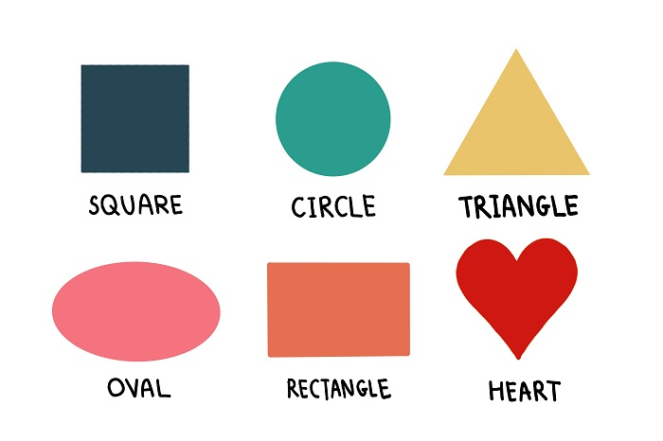

Tapa wha rite Porowhita Tapatoru

Porotītaha Tapa whā ngakau

**E mohio ana ahau kei te tangi tāku tīmata.**

(I know my beginning sounds)

|  |  |  |  |
| --- | --- | --- | --- |
| Cartoon an apple Royalty Free Vector Image - VectorStockāporo | 18 Free Wild birds Flashcards in maori (PDF files) | Puzzles: Ika (Moana Series)ika | Ecology Acacia Bowl 30x10cm | Briscoes NZoko |
| Umu Pizza – A Style Collector | HORSE SIMULATOR 3D - Play Horse Simulator 3D on Pokihoiho | Lifespan of a Dog: A Dog Years Chart by Breedkuri | Manu - NZ native bird palettes • Manu |
| ʻŌlelo of the Day — Hawaiian Word of the Day: Niho — Tooth He maka no...niho | Banana equivalent dose - Wikipediapanana | Buy Mr Vintage Oma Rapeti Infant&#39;s T-Shirt (12-18 Months) at Mighty Ape NZrapeti | Tatra Trucks HD Stock Images | Shutterstocktaraka |
| Waka Itiwaka | https://greengrubsgardenclub.com/wp-content/uploads/2021/01/NG-SQUARE-COVER-600x600.jpg ngata | Te whare tapa whā and wellbeing | Health Navigator NZ whare |  |

**Ka taea e au te tatau tetahi ki tekau.**

(I can count one to ten)

