Rāhina | Rātū | Rāapa | Rāpare | Rāmere
Tuhituhi
Me oti pai ngā mahi ia rā anō hoki me tukuna ki roto i a koutou kōpaki kua whakaritea i roto i te google drive.

Tuhinga whakaahua  He pikitia kei raro iho tuhia i ngā momo āhuatanga o te pikitia, ngā momo tae, ngā momo taputapu kei roto i te pikitia, whakamārama mai i te wāhi o te pikitia. Ko wai kei roto i te pikitia.  Whakautu i ēnei pātai.  - He aha kei roto i tēnei pikitia?  - He aha ngā tae kei roto i te pikitia.?  - Ko wai kei roto i te pikitia?  - He aha te āhua o te rangi?  - He aha te mahi a te kōtiro.  Tuhia he paku kōrero paki e pā ana ki te pikitia nei. | Tuhinga whakaahua  He pikitia kei raro iho tuhia i ngā momo āhuatanga o te pikitia, ngā momo tae, ngā momo taputapu kei roto i te pikitia, whakamārama mai i te wāhi o te pikitia. Ko wai kei roto i te pikitia.  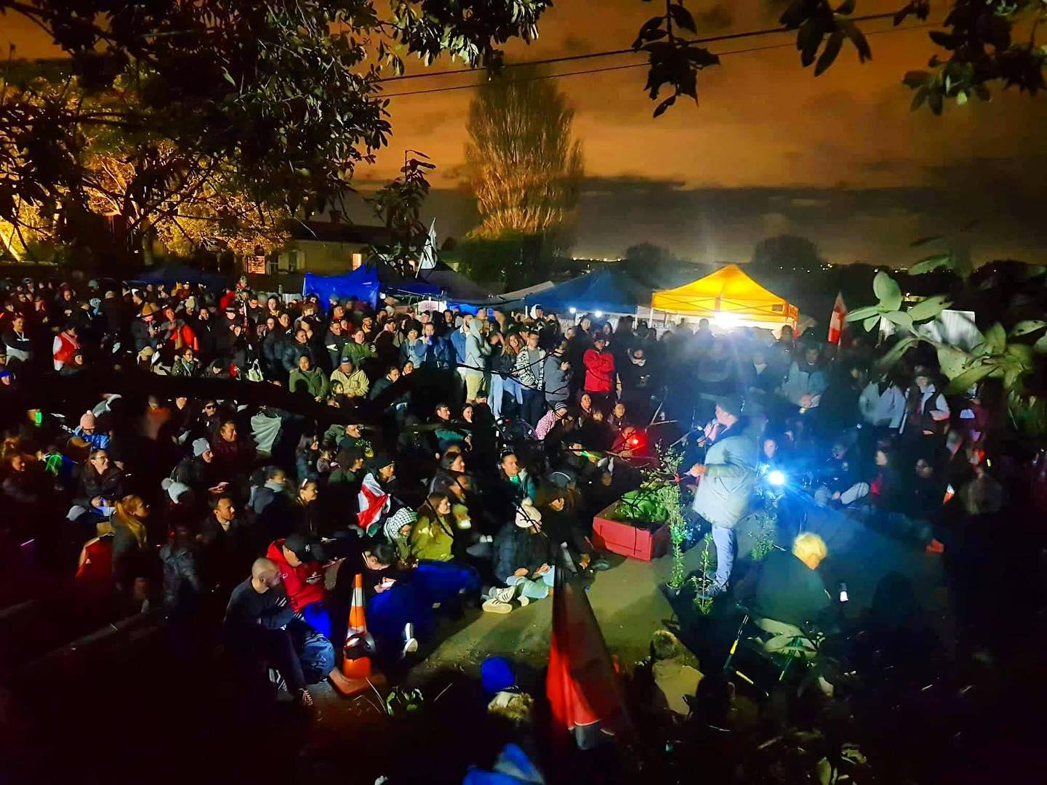  Whakautu i ēnei pātai.  - He aha kei roto i tēnei pikitia?  - He aha ngā tae kei roto i te pikitia.?  - Ko wai kei roto i te pikitia?  - He aha te āhua o te rangi?  - He aha te mahi a ngā tangata maha.  Tuhia he paku kōrero paki e pā ana ki te pikitia nei. | Tuhinga whakaahua  He pikitia kei raro iho tuhia i ngā momo āhuatanga o te pikitia, ngā momo tae, ngā momo taputapu kei roto i te pikitia, whakamārama mai i te wāhi o te pikitia. Ko wai kei roto i te pikitia.  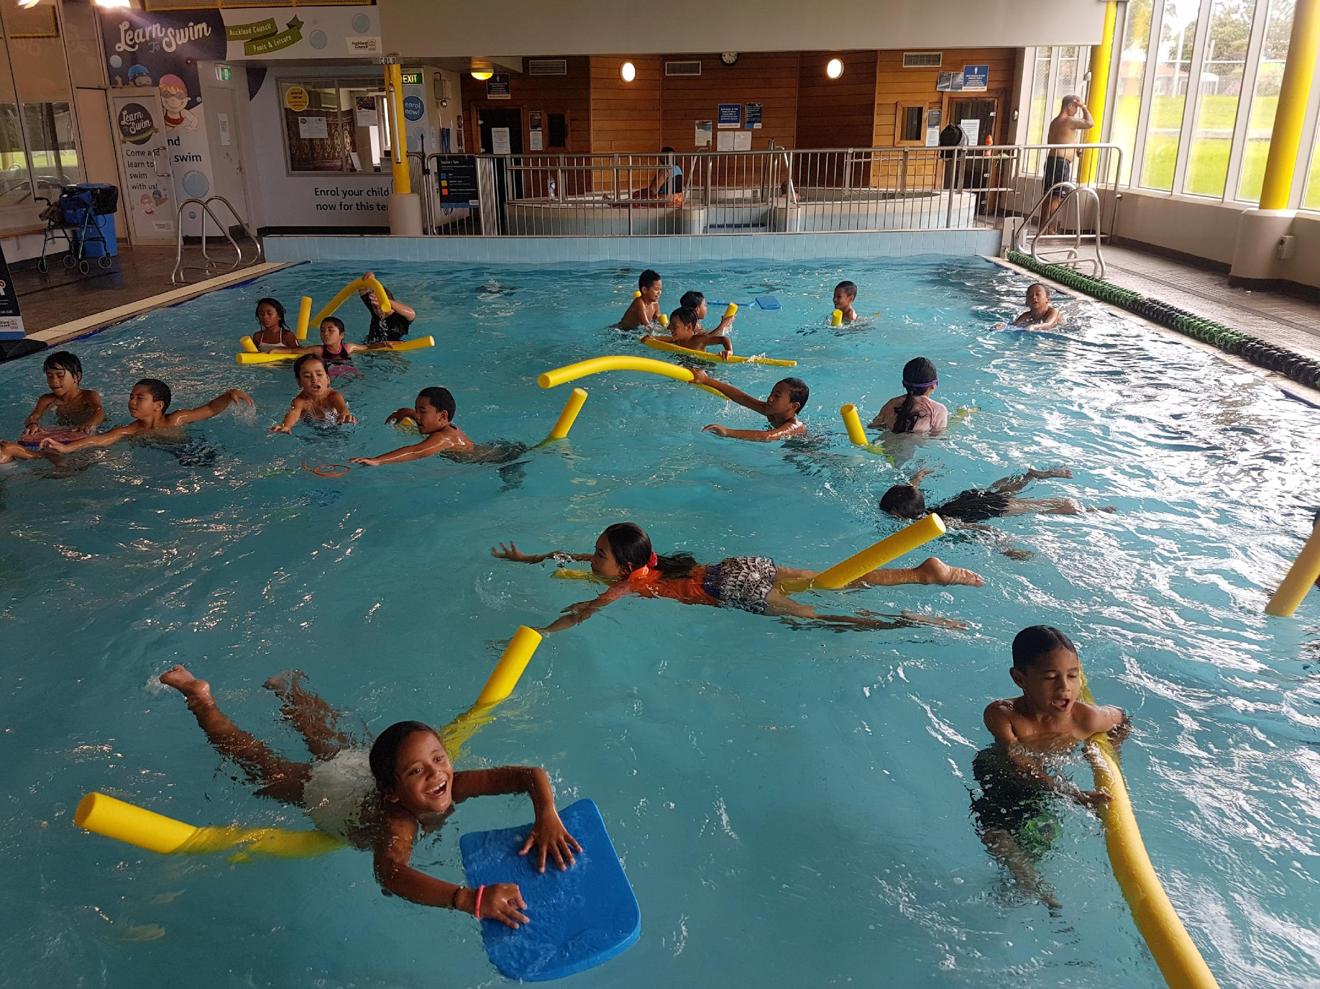  Whakautu i ēnei pātai.  - He aha kei roto i tēnei pikitia?  - Kei hea ngā tamariki?  - He aha ngā tae kei roto i te pikitia.?  - Ko wai kei roto i te pikitia?  - He aha te āhua o te rangi?  - He aha te mahi a ngā tamariki.  Tuhia he paku kōrero paki e pā ana ki te pikitia nei. | Tuhinga whakaahua  He pikitia kei raro iho tuhia i ngā momo āhuatanga o te pikitia, ngā momo tae, ngā momo taputapu kei roto i te pikitia, whakamārama mai i te wāhi o te pikitia. Ko wai kei roto i te pikitia.  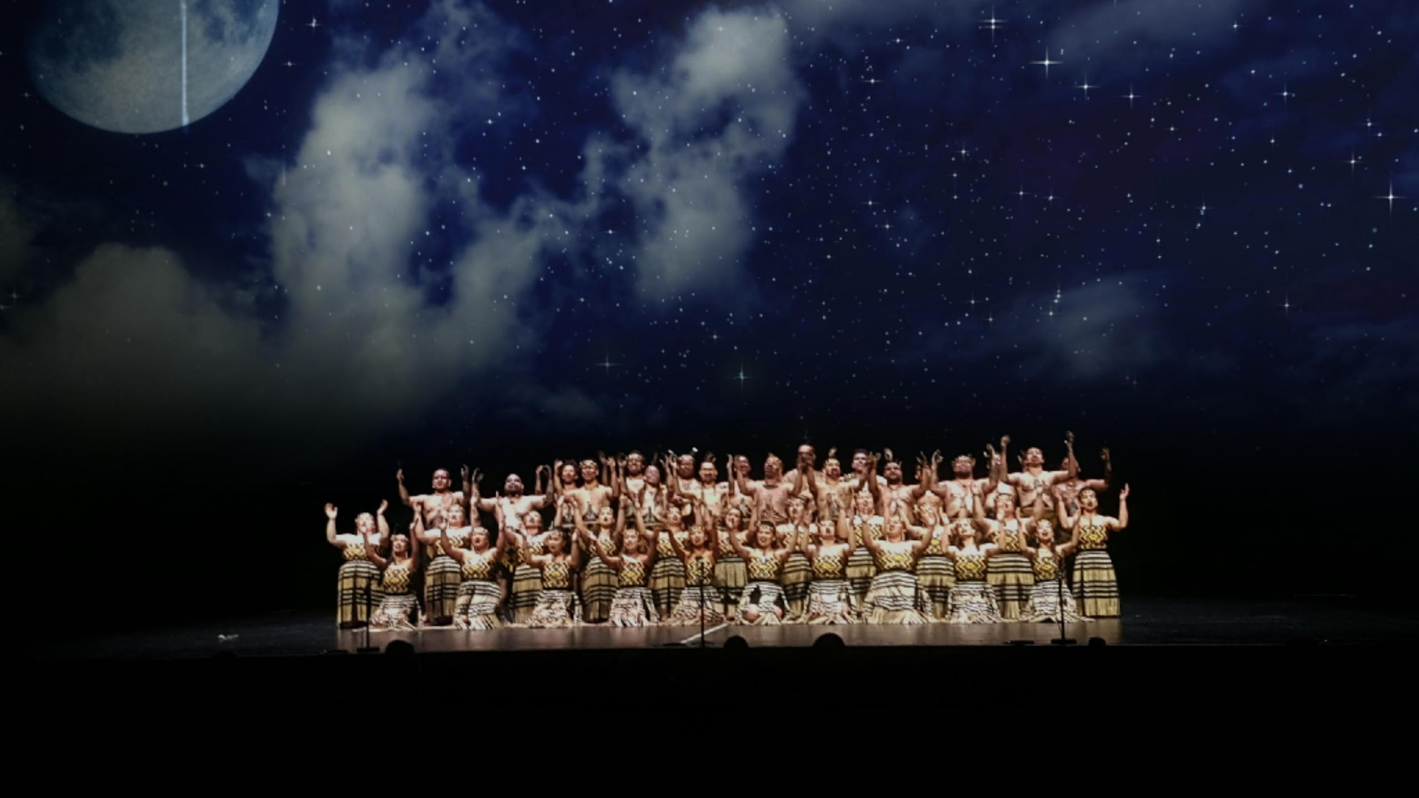  Whakautu i ēnei pātai.  - He aha kei roto i tēnei pikitia?  - He aha ngā tae kei roto i te pikitia.?  - Ko wai kei roto i te pikitia?  - He aha te āhua o te rangi?  - He aha te mahi a ngā tangata kei roto i te pikitia nei..  Tuhia he paku kōrero paki e pā ana ki te pikitia nei. | Whakaoti mahi.  Whakaoti i ngā mahi kāore anō koe kua oti i ngā rākua taha ake nei.  Complete all mahi you have not yet finshed from previous days.

