PĀNUI - READING
Rāhina | Rātū |  |  | Rāapa | Rāpare | Rāmere
Pick a book from the selections of books in your school pack.  Read the book two times then you need to answer the following questions.  He aha te taitara, tapanga rānei?  What is the title?  Ko wai te kaituhi  Who wrote the book?  Ko wai te kaitā pikitia  Who created the pictures?  Ko wai ngā kiripuaki?  Who are the characters?  He aha te ngako o te pukapuka?  What is the main idea of the book?  he aha tō whārangi tino pai?  what is your favourite page?  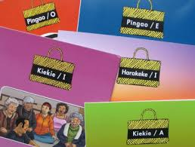  Draw a picture of your favourite page. |  | Carry on with mahi pānui from yesterday if you have finished below is extra activities for you to complete.  Ngā mahi.  Hangaia i tētahi kupu huna e whakamahi ana i ngā kupu mai i te pukapuka i pānuitia e koe inanahi.  Create a wordfind using the words from the book you read yesterday. | Pick a book from the selections of books in your school pack.  Read the book two times  Write out 8 words for each category below from the book  - Kupu āhua  adjective  - Kupu Mahi  noun  - Kupu ingoa  verb |  | Kua pānuitia e koe kia rua ngā pukapuka. Mai i aua pukapuka e rua tuhia ngā kupu hou katoa ka rapu i ngā whakamāramatanga mō aua kupu.  You have read two books this week now you need to write all the words that are new to you and look for the meaning of each word.  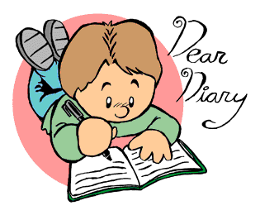  . |  | Whakaoti i ngā mahi kāre anō kia oti.

