General Knowledge Questions - ‘GKQS’
New Zealand Y0-2 sheet 2
See if you can find out all the answers
- What colour is whero?
- Name 3 animals that live in the sea.
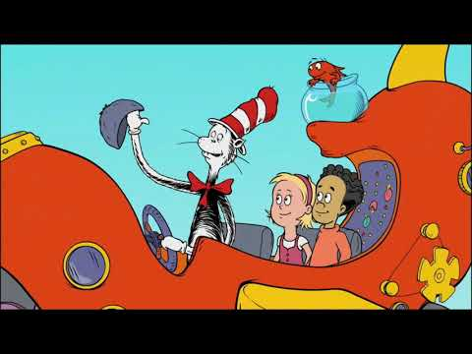
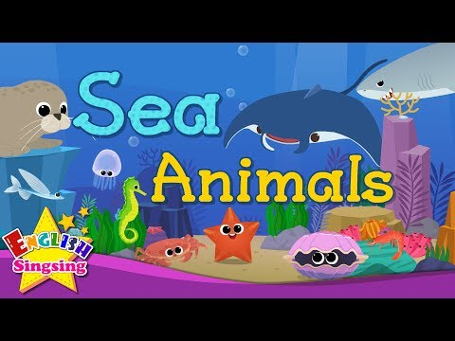
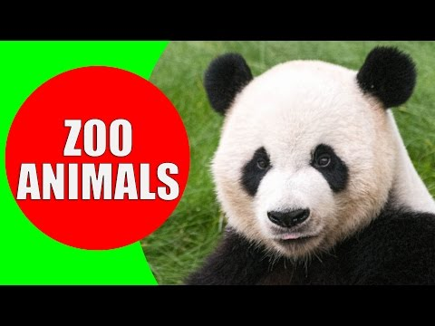
- Where in NZ would you find a lion?

- How many fingers are there on two hands?
- Who is the main character in The Cat in the Hat Book?
- When would you see the moon?
- What is Sponge Bob?
- Who is the person on the NZ $5.00 note?
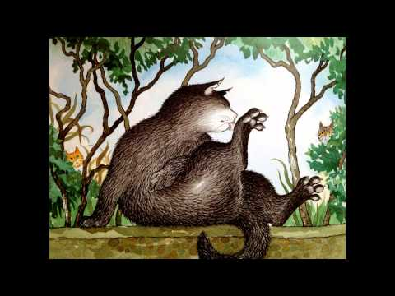
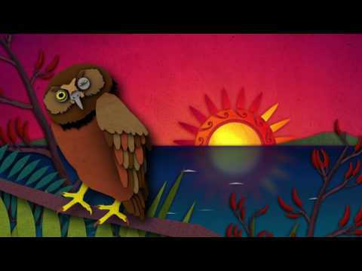

- Where in New Zealand would you find a fantail?
- The Kiwi is a __________________.
- What is the name of Elsa’s sister in the movie Frozen?
- Name 3 animals that live on a farm.
- Where in NZ is the “Beehive” building?
- What two colours make green?
- Who is Scarface Claw?

