General Knowledge Questions - ‘GKQS’
New Zealand Y0-2
See if you can find out all the answers
- What is the name of Sponge Bobs good friend?
- What is the name of the bird in the film Moana?
- Where in NZ would you find lots of sheep?
- What is the Maori word for yellow ?
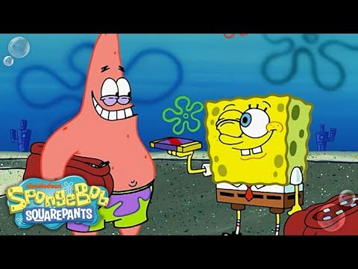
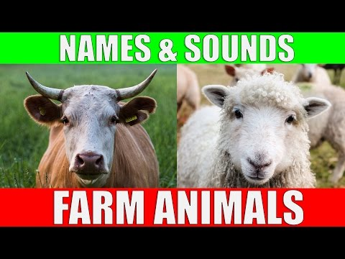

- What are 3 things that can fly?
- Name the 3 colours on the NZ Flag
- What is the name of the New Zealand special bird that cannot fly?
- Name the town that has the Giant Lemon and Paeroa bottle in it
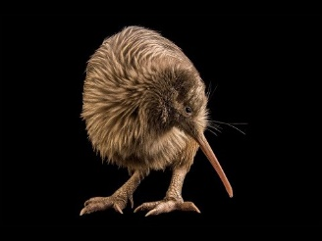

9. Who is the person on the $10 note?
10. What does a cow eat to make milk?
11. Where in NZ would you find the Sky Tower?
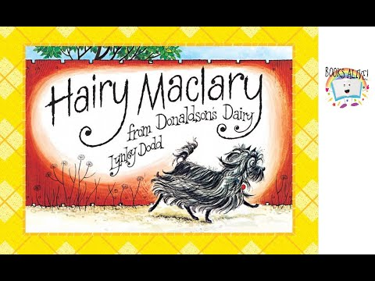
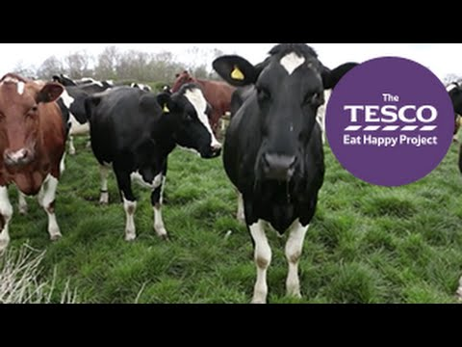
12. Name 3 characters from the Hairy McClary books by NZ author Lynley Dodd.

