General Knowledge Questions - ‘GKQS’
New Zealand
See if you can find out all the answers
- What is the name of NZ’ s Prime Minister?
- What is the name of the two harbours that are on either side of Auckland?
- Where in NZ can you find Lake Whakatipu?
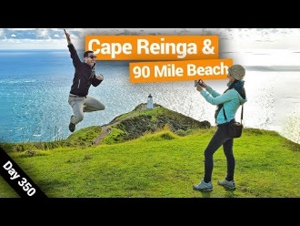
- What is the reason most people visit Cape Reinga?

- Where was Bruce McLaren born and why is he famous?
- Name 3 NZ things that are called Kiwiana.
- What is the name of the steepest street in the world that is in Dunedin?
- Name the 3 native birds of New Zealand.
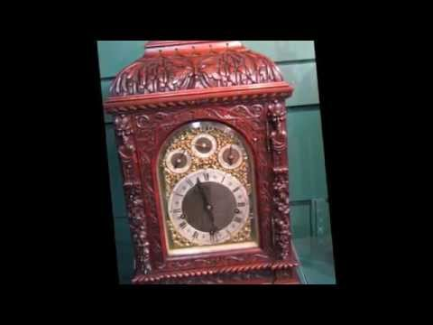
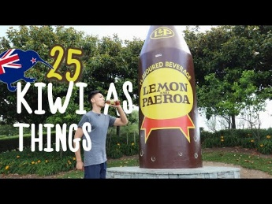
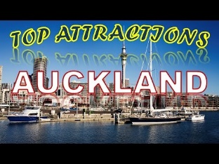

9. Where in NZ would you find Rainbows End and what is it?
10. What is the Maori word for red?
11. Where in NZ would you find “Claphams Clock Museum”?
12. Name 3 New Zealand children’s authors and a book that they have written.

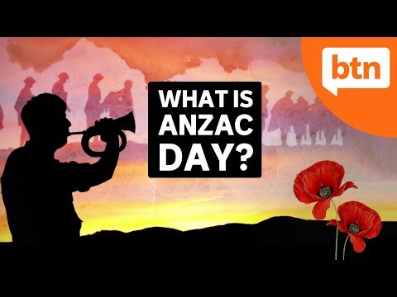
What does ANZAC stand for and why do we celebrate it on April the 25^{th?}

