General Knowledge Questions - ‘GKQS’
New Zealand
See if you can find out all the answers
- What is the name of the tallest mountain in NZ?
- What is the name of the longest river in NZ?
- Where in NZ can you find boiling mud pools?
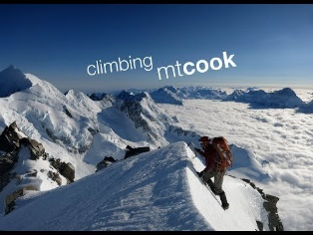
- What is the special attraction at Waitomo?
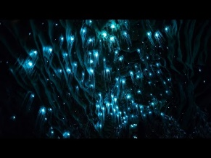

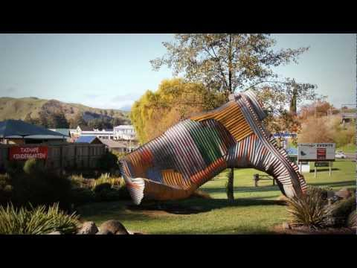
- What is the name of the town that has a gumboot statue in its main street?
- Name 3 NZ things that have been named after Captain Cook
- What is the name of the New Zealand man who was famous for climbing Mt Everest?
- Name the 3 towns that have these Icons in their streets
A giant lemon and Paeroa bottle, a carrot and a kiwifruit.

9. Where in NZ would you find The Beehive and what is it?
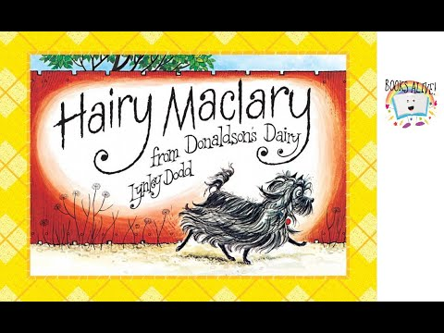
10. What is the Maori name for Auckland?
11. Where in NZ would you find and aluminium smelter?
12. Name 3 characters from the Hairy McClary books by NZ author Lynley Dodd.

