Letter to the Applicant:
Kura Ruumaki- Position 2024
Wednesday 28 February 2024
Teenaa Koe, Ko Maungaroa te maunga Ko Waikato te awa Ko Te Manukanuka o Hoturoa te moana Ko Tainui te waka Ko Ngaa Hau e Whaa te marae Ko Ngaati Tamaoho te hapuu
Thank you for your interest in the permanent Kaiarahi I te Reo Positions at Pukekohe North School commencing officially on Monday 29 April 2024. The timeline for the position is as follows:
- Advertised from Thursday 29 February 2024
- Applications close on Tuesday 12 March at 3.00.p.m.
- Interviews take place from 3.30.p.m. on Thursday 14 March 2024 = from 3.00.p.m.
- Referees will be contacted on Friday 15 March 2024
- Success applicant notified Friday 15 March 2024
- Earlier start dates can be negotiated

We welcome your questions or school visits to learn more about our school. Please phone 0800 785 366 to make an appointment to talk to a Senior Manager.
The interview panel will consist of Kura Ruumaki Leaders Pikiteora Mura-Hita, Atarangi Cook, a Board member and Principal Jim Stafford-Bush
We look forward to receiving your application. Please ensure you submit the completed application form along with your Curriculum Vitae when applying for this position.
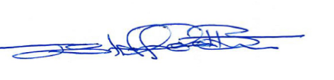
Jim Stafford-Bush Principal. Pukekohe North School

